Module Code: AN6002
Module Title: Analytics And Machine Learning In Business

Group: Section A_4

Group Members:

Ang Wei Hao Welthan
Felda Everyl
Guo Yutong
Kaitwatcharachai Onnicha
Joanne Quek

Project Title: Global AI Trust and Attitudes

Introduction
Artificial intelligence is increasingly involved in decisions and tasks that affect everyday life. Whether people are willing to rely on these systems matters to organizations seeking to introduce AI and to the public who experience its consequences. However, higher trust does not necessarily mean better judgement. Useful systems may be avoided when trust is too low, while errors may go unchallenged when trust is too high. The practical aim is therefore calibrated trust: reliance that reflects what an AI system can reliably do, together with awareness of when its output needs to be questioned.
Trust involves expectations about competence, safety and the intentions of those responsible for a system. These expectations may develop through experience, perceived benefits, knowledge of AI and confidence in safeguards. Social and economic circumstances may also influence how people interpret the opportunities and risks. This provides the conceptual basis for examining whether countries with different experiences and perceptions report different levels of trust.
The aim of this project is to examine global AI trust through country comparisons, statistical relationships and predictive modelling. Specifically, we address four questions: how trust differs across countries and regions; which factors seem related to trust; whether those factors can predict a country’s trust level; and whether public perception of AI is becoming more positive. The findings suggest substantial differences between countries and strong associations with perceived safeguards and workplace benefits. A simple regression model captures much of the variation within this dataset, although its performance is likely optimistic. The separate trend analysis suggests a slight improvement in benefit perception, but does not establish a clear overall increase. The project also uses supervised regression to predict the percentage of people in each country who trust AI. It predicts a percentage rather than assigning a label such as “high trust” or “low trust”. The analysis compares countries as a whole and therefore cannot tell us whether an individual’s trust matches an AI system’s reliability. As the data do not track individuals over time, they also cannot show how a person’s trust changes after the system makes a mistake.
Data and Analytical Approach
The main dataset contains 47 countries and 43 variables. It combines country identifiers, region, economy type, GDP per capita, population and an overall sentiment label with survey percentages concerning trust, acceptance, benefits, risks, literacy, training, organizational adoption and workplace outcomes. Each row represents a country rather than an individual respondent. Initial checks found no missing values, duplicate rows or duplicate countries in the main dataset. The percentage of people who trust AI, ranges from 25% to 79%.
The supporting benefit-perception dataset contains 32 countries and six variables. It records the percentage believing that AI benefits outweigh drawbacks in 2023 and 2024, together with the percentage-point change. This dataset contains four missing cells. China and Switzerland each lack a 2023 value and the corresponding change from 2023 to 2024.The existing trend analysis excludes these two countries and uses the 30 complete country pairs. Indonesia, Thailand, Peru and Malaysia appear in this dataset but not in the main trust dataset. The trend dataset is used separately and is not an input to the prediction model.
The analytical approach moves from description to explanation and prediction. Country rankings, economy comparisons and regional summaries establish the distribution of trust. Correlations assess which indicators tend to move together with trust, while feature grouping reduces repeated information before modelling. Several regression methods are then compared against a baseline that predicts average trust. Finally, paired changes in benefit perception provide a limited view of change over time.
Means and medians in these analyses give each country equal weight. They should therefore be interpreted as summaries of the countries included, rather than population-weighted estimates of the world’s attitudes. A percentage-point change is the difference between two percentages: for example, moving from 40% to 45% is an increase of five percentage points.
Figure 1. Dataset sizes and data quality checks datasets.
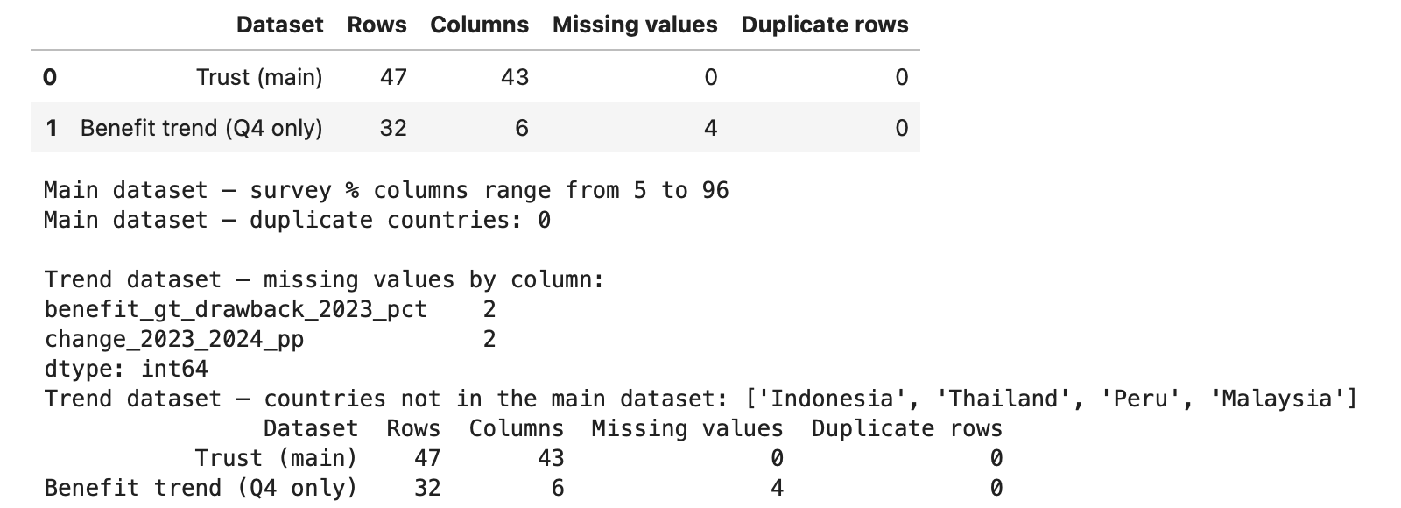
Differences in Trust Across Countries and Regions
The country comparison shows that trust in AI varies substantially. Nigeria reports the highest trust at 79%, followed by India at 76%. Finland reports the lowest trust at 25%, followed by Japan at 28%. These figures suggest that a single global message about AI adoption would overlook important differences in the attitudes of the countries studied.
Figure 2. Top 10 and Bottom 10 AI trust by Country.
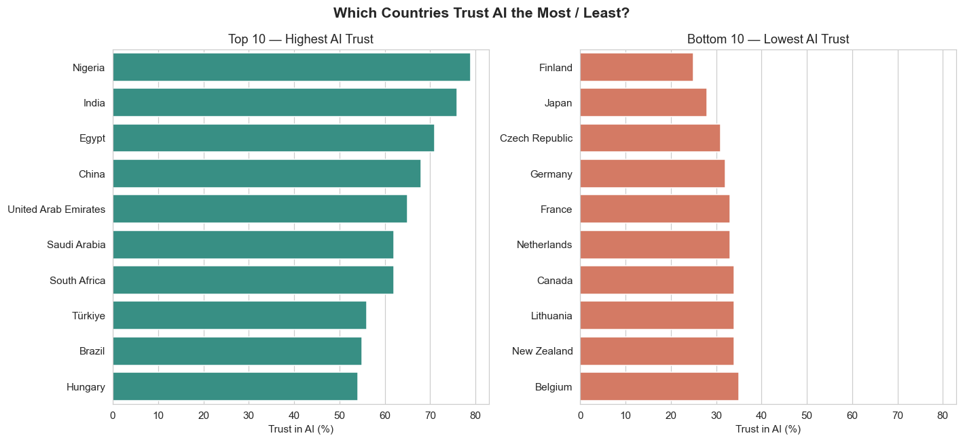

Economy Type
Emerging economies have an average trust level of 57.2%, compared with 39.4% for advanced economies. The emerging group contains 17 countries and has a standard deviation of 11.6 percentage points; the advanced group contains 30 countries and has a standard deviation of 7.3 points. Thus, emerging economies have higher average trust but also more variation within the group. The Mann–Whitney comparison records U = 45.5 and p < 0.001. This supports a difference between the observed groups, without establishing that economic development causes the difference.

Regional Patterns
Region | Mean trust | Countries
Africa | 70.7% | 3
Western Asia | 58.5% | 4
Eastern Southern and Central Asia | 53.2% | 5
Latin America and Caribbean | 49.0% | 6
Southern Europe | 42.6% | 5
Eastern Europe | 41.4% | 5
Northern and Western Europe | 38.9% | 15
North America | 37.5% | 2
Oceania | 35.0% | 2

Africa and Western Asia have the highest regional means, while Oceania and North America have the lowest. These are summaries of the sampled countries, not conclusions about entire regions. Africa includes only three countries, while Oceania and North America each include two. Eastern, Southern and Central Asia also has a wide spread, with trust ranging from 28% to 76%. Regional averages should therefore be read alongside the individual countries.
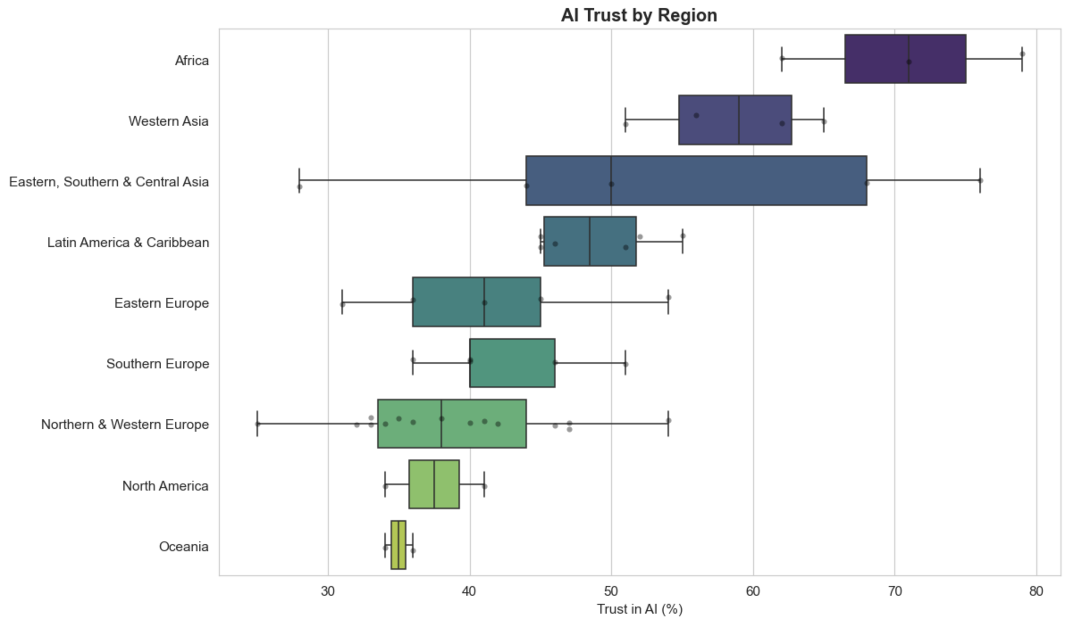
Figure 3. AI trust by Region.
Factors Associated With AI Trust
The correlation analysis suggests that countries reporting more benefits, stronger AI capability and greater confidence in safeguards also tend to report higher trust.
Indicator | Pearson correlation with trust
AI increased efficiency | 0.896
Safeguards are sufficient | 0.894
AI increased revenue | 0.887
Organization provides training | 0.861
Regular workplace AI use | 0.853
AI literacy and skills | 0.847
AI training | 0.832
Risks outweigh benefits | −0.780
Regulation is required | −0.566

The strongest positive relationships concern practical gains and perceived protection. This suggests that willingness to trust AI is linked both to whether it appears useful and to whether people believe its risks are being managed. Expected and experienced benefits are also positively associated with trust, with Spearman rank correlations of 0.692 and 0.739 respectively. GDP per capita has a negative rank correlation of −0.514, consistent with the lower average trust observed in advanced economies.
There is less consistent evidence for some concerns. Worry about negative impacts has a significant Pearson relationship of −0.324, but its Spearman relationship of −0.162 is not significant after the notebook’s multiple-testing correction. This difference suggests that the linear result may be sensitive to particular observations. Concern about elections, uncertainty about online content, demand for misinformation laws and the top-risk indicator do not show significant relationships with trust in the corrected comparisons.
Acceptance also differs from trust. In the notebook’s comparison, acceptance exceeds trust across countries. Lithuania illustrates this distinction: acceptance is 76% while trust is 34%. People may be willing to accept AI without feeling confident about it. However, these are separate country percentages and do not identify whether the same individuals both accept and distrust AI.
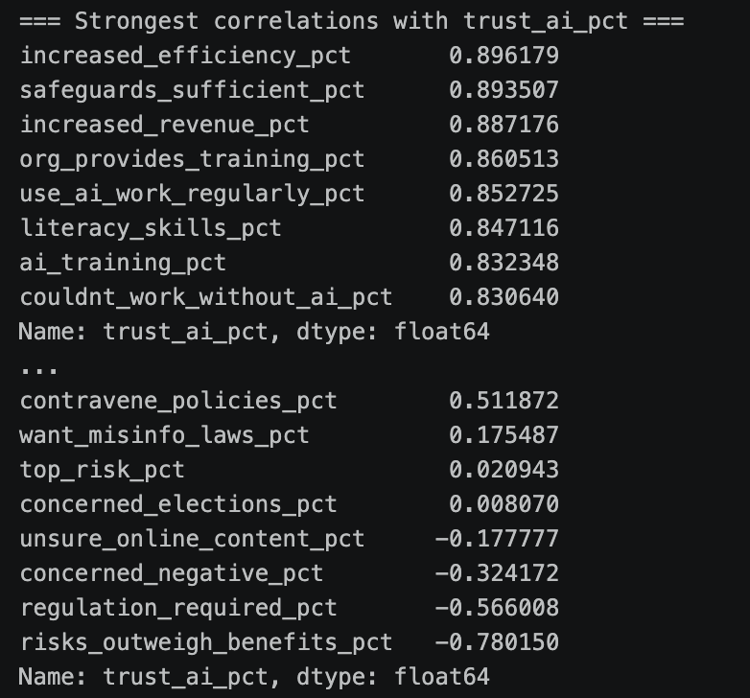
Figure 4. Selected correlations between country-level AI trust and survey indicators.
Choosing Inputs for Prediction
Many of the possible predictors provide similar information. After removing country identifiers and attitude measures that closely resemble trust, the feature-selection report examines 36 possible inputs. The median strength of the relationships between these inputs is 0.52, measured using absolute Spearman correlation. In addition, 53% of the pairs have a correlation strength of at least 0.5. This overlap would make it difficult to identify each variable’s separate contribution if all were included in a model, especially with only 47 countries.
To reduce this overlap, the report uses hierarchical clustering to place variables with similar patterns into groups. It measures similarity using absolute Spearman correlation and joins groups based on their average similarity. A distance threshold of 0.25 produces 15 groups. Here, clustering helps identify predictors that provide repeated information.
A single selection criterion is insufficient to decide which predictors to keep. For example, 24 of the 36 candidates have a strong, statistically significant correlation with trust (absolute Spearman correlation ≥ 0.5, p < 0.01). Correlation alone therefore leaves many possible predictors. It also assesses each variable separately, without showing whether it provides additional information alongside other inputs.
With a small dataset, selection based on one measure may be sensitive to chance or particular countries. The analysis therefore combines four methods: correlation with trust, mutual information to detect potentially non-linear relationships, Lasso selection across 200 bootstrap samples, and random-forest permutation importance assessed on held-out countries. Lasso and random forest consider predictors together with the other inputs, while resampling helps assess whether their usefulness is consistent. Agreement across these methods provides stronger support for selection, although it does not eliminate uncertainty.
A predictor must pass at least three of the four tests and have the strongest absolute correlation with trust within its cluster. This selects three indicators: perceived safeguard sufficiency, workplace efficiency gains and inability to work without AI. Log GDP per capita is added as a control for economic context, giving four final inputs.
Selected input | Spearman correlation | VIF
Safeguards are sufficient | 0.83 | 3.71
AI increased efficiency | 0.82 | 5.13
Could not work without AI | 0.72 | 3.70
Natural log of GDP per capita | −0.51 | 1.86

All four rank correlations have p < 0.001. VIF, the variance inflation factor, indicates how much a predictor overlaps with the other inputs. The maximum is approximately 5.1, substantially lower than the maximum of 167 among the original candidates, although some overlap remains. Logarithmic GDP reduces the influence of very large monetary values.
Country names and codes are excluded because they identify records. Acceptance, the judgement that risks outweigh benefits and the sentiment label are excluded from prediction because they closely resemble the outcome being predicted. Region is excluded because nine categories are sparse across 47 records. Economic context is represented by log GDP rather than overlapping economy and regional categories.
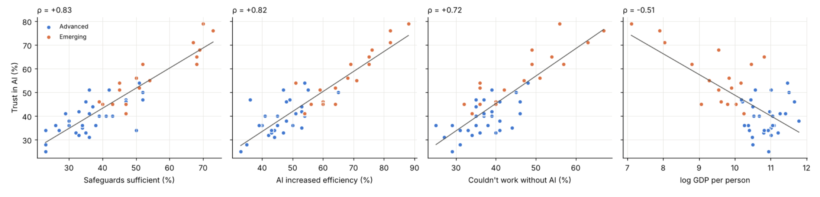
Figure 5. Relationships between AI trust and the four selected predictors.

Model Development and Evaluation
Four models are compared against a baseline that predicts the training countries’ average trust. Linear regression combines the inputs in a formula, while Ridge adds a penalty to stabilize its coefficients. A decision tree splits countries into groups, and a random forest averages predictions from many trees. This comparison tests whether more complex models improve prediction.
The models are evaluated using five-fold cross-validation repeated with three different shuffles. For each shuffle, countries are divided into five groups; the model learns from four groups and predicts trust for the remaining group. Each country receives a prediction from a model that did not see that country during training or setting selection. For models with adjustable settings, an inner five-fold procedure selects these settings using only the training countries. Scaling for Linear and Ridge regression is performed within their model pipelines.
The existing comparison over 100 shuffles supports this evaluation choice. A single 70/30 split produces linear-regression mean absolute errors ranging from 2.17 to 5.29 percentage points. Repeated cross-validation narrows that range to 3.49–3.82 points, while typical errors remain close to 3.6 points. Cross-validation makes the measurement less dependent on one split; it does not itself improve the model.
Model | MAE pp | RMSE pp | R² | Within 5 pp
Average baseline | 9.86 | 12.59 | −0.04 | 29%
Linear regression | 3.66 | 4.68 | 0.86 | 73%
Ridge regression | 3.67 | 4.64 | 0.86 | 71%
Decision tree | 5.91 | 6.95 | 0.68 | 43%
Random forest | 4.35 | 5.40 | 0.81 | 65%

MAE measures average prediction error, while RMSE gives more weight to large errors. R² measures how well predictions account for differences in observed trust, rather than the percentage of correct predictions. Linear and Ridge regression perform similarly, so Linear regression is chosen for its simplicity, with MAE of about 3.7 percentage points and R² of 0.86. Tree models perform worse, and tuning changes MAE by less than 0.1 point, suggesting that model choice matters more than fine-tuning.
The “within 5 pp” column averages performance across the three shuffles. It is distinct from the count obtained after averaging each country’s three predictions, discussed next. The results support useful prediction within the sample, but require qualification because the four inputs were selected using all 47 countries before this evaluation.
Figure 6. Model performance comparison using repeated five-fold cross-validation.
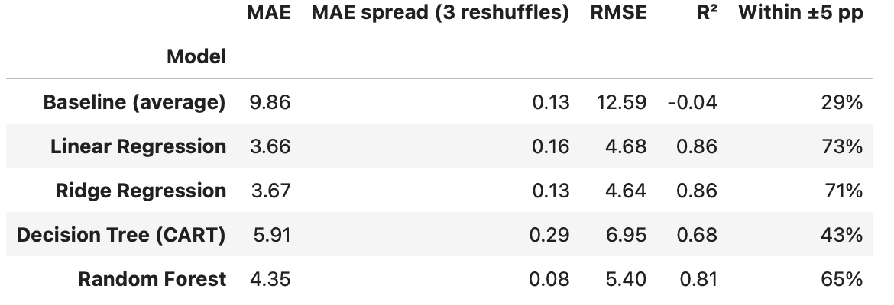
Prediction Results and Their Limits
The final linear model is fitted to all 47 countries after evaluation. Its recorded formula has an intercept of 20.7 and coefficients of 0.37 for safeguards, 0.31 for efficiency, 0.25 for inability to work without AI and −1.75 for natural-log GDP. The survey inputs are entered as percentages on the 0–100 scale. This fitted formula describes the observed relationships; its coefficients should not be interpreted as the effects of policy interventions.
Holding other inputs fixed, a ten-point increase in perceived safeguard sufficiency corresponds to 3.7 points higher predicted trust, with a 95% bootstrap range of 1.5–5.8 points. The corresponding efficiency estimate is 3.1 points, with a range of 0.6–6.1. For inability to work without AI, the estimate is 2.5 points, but the range of −0.2 to 4.9 crosses zero. Its separate contribution is therefore less certain. Doubling GDP per capita corresponds to 1.2 points lower predicted trust, with a range of −2.1 to −0.2. These ranges assume the chosen inputs are fixed and do not include uncertainty from feature selection.
Using the average of each country’s three cross-validation predictions, 35 of 47 countries fall within five percentage points of actual trust. Eight have errors of five to eight points and four have larger errors. Lithuania has actual trust of 34% and predicted trust of 47.6%. Israel, Hungary and Spain have actual trust of 51%, 54% and 51%, compared with predictions of 40.8%, 43.9% and 41.3%. These misses show that similar safeguards, workplace gains and economic conditions do not fully account for national attitudes.
Some countries with higher trust than predicted also report greater AI benefits or concern about being left behind. These omitted factors may help explain prediction errors, but do not establish causation. Political conditions, media coverage and recent events cannot be assessed from this dataset. Model performance may be optimistic because all countries helped select the four inputs before evaluation. A separate Ridge benchmark that selects inputs within each fold reports R² of 0.73 and RMSE of 5.0, compared with 0.78 and 4.4 using the fixed inputs. However, its different selection method and calculation of R² mean these scores cannot directly correct or be compared with the final linear model’s results.
Figure 7. Predicted versus actual AI trust using averaged cross-validation predictions.
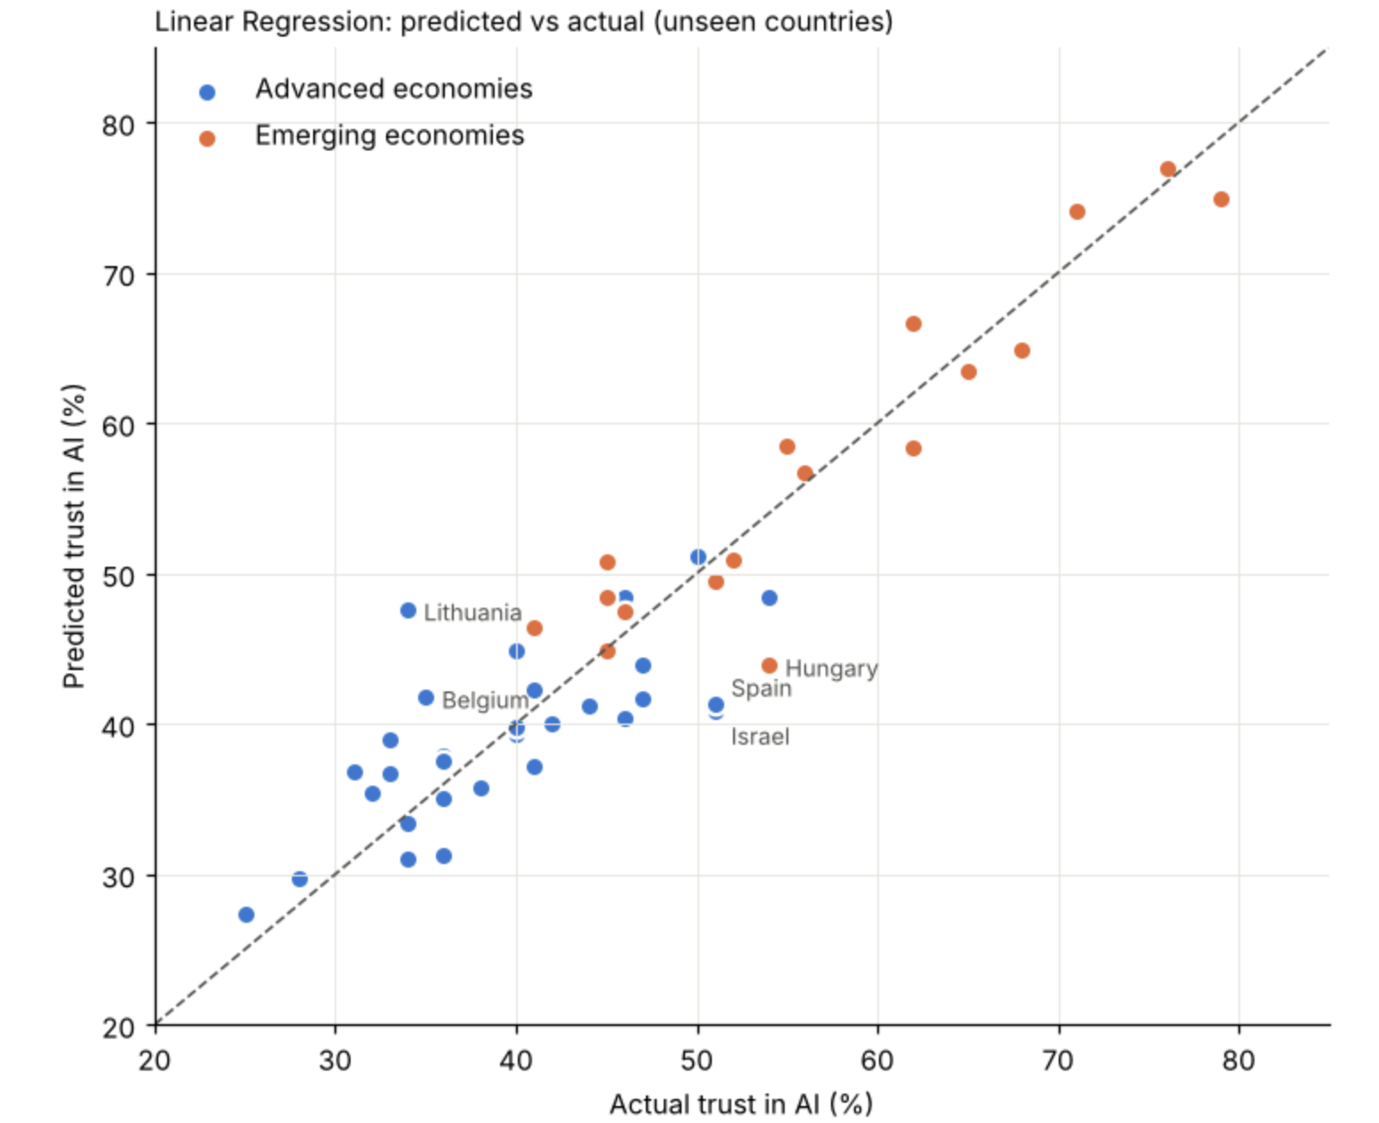
Changes in Public Perception of AI
The supporting dataset addresses whether public opinion is becoming more positive by comparing the proportion who believe AI benefits outweigh drawbacks. This is a measure of benefit perception, rather than the same trust outcome used in the main model. It covers 2023–2024 and should not be described as a change in trust during 2025. China and Switzerland are omitted from the paired comparison because their 2023 values are missing.
Across the 30 complete country pairs, average benefit perception rises from 54.1% in 2023 to 54.6% in 2024. The recorded mean change is +0.47 percentage points and the median change is +1.50 points. Seventeen countries improve, nine decline and four remain unchanged. Thus, more countries move in a positive direction, but the average increase is small.
Country | 2023 | 2024 | Change pp
Germany | 42% | 47% | +5
Ireland | 40% | 45% | +5
Hungary | 47% | 51% | +4
New Zealand | 44% | 48% | +4
Australia | 40% | 44% | +4
Brazil | 64% | 56% | −8
Netherlands | 43% | 36% | −7
Malaysia | 69% | 63% | −6
Japan | 52% | 48% | −4
Mexico | 73% | 70% | −3

Germany and Ireland show the largest increases, while Brazil, the Netherlands and Malaysia show the largest declines. The larger negative movements help explain why the mean increase is smaller than the median. This also shows that public perception is not moving uniformly across countries.
The Wilcoxon signed-rank test gives p = 0.3584 and the one-sample t-test of the changes gives p = 0.4797. Neither provides statistically significant evidence of an overall shift at the conventional 0.05 level. This does not prove that attitudes are unchanged; it means the observed increase is insufficient to establish a clear shift with these data. The small country sample, rounded percentages and only two observation years limit the conclusion. The most defensible answer is that benefit perception leans slightly more positive, but a broad improvement has not been demonstrated.
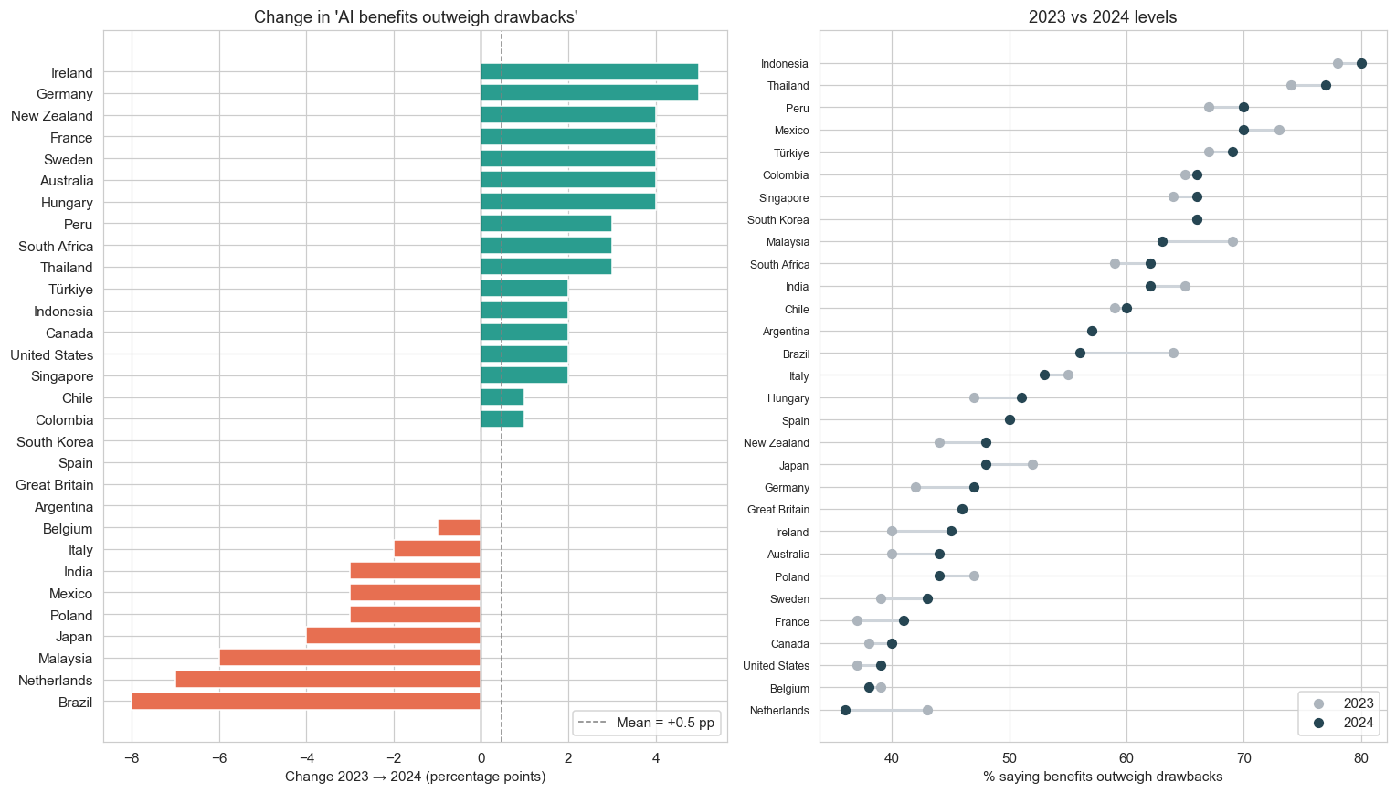
Figure 8. Changes in perceptions that AI benefits outweigh drawbacks across 30 countries between 2023 and 2024.
Discussion

How does trust in AI differ across countries and regions?
The first question examines whether trust in AI is similar across countries or differs according to geographical and economic context. The report compares country trust percentages, average trust in advanced and emerging economies, and regional patterns.
Trust varies considerably among the countries studied. Nigeria and India report the highest levels, at 79% and 76%, while Finland and Japan report the lowest, at 25% and 28%. Emerging economies average 57.2%, compared with 39.4% for advanced economies. The statistical comparison supports a difference between these two groups. Among the sampled regions, Africa and Western Asia have the highest average trust.
These findings suggest that people in different countries may respond differently to the introduction of AI. Organizations should therefore consider local attitudes when explaining AI applications and addressing concerns. However, the analysis does not establish why these differences occur. Some regions contain only two or three countries, and a national average does not represent every resident’s views. The findings describe the countries included rather than entire regions or populations.
What factors seem related to AI trust?
The second question examines which experiences and perceptions tend to accompany higher or lower trust. The report assesses relationships between trust and indicators such as perceived safeguards, workplace benefits, training, literacy, AI use and economic conditions.
Countries where more people believe safeguards are sufficient or report efficiency gains from AI tend to have higher trust. Training, literacy and regular workplace use are also positively associated with trust. In contrast, countries where more people believe risks outweigh benefits tend to have lower trust. Countries with higher GDP per capita tend to report lower trust in AI. This is consistent with the finding that advanced economies have lower average trust than emerging economies.
The findings suggest that trust is linked to both usefulness and perceived protection. People may feel more comfortable with AI when they see practical benefits and believe its risks are being managed. However, these factors overlap, so the analysis cannot identify one clear cause of trust. The relationship could also work in both directions: trusting AI may encourage its use or make safeguards appear more adequate.
Acceptance is also higher than trust across the countries studied. This suggests that willingness to accept AI should not be treated as evidence of confidence in it. People may accept its presence while retaining concerns, although the country-level data cannot show whether the same individuals hold both views.

Can AI trust be predicted from these factors?
The third question examines whether a small set of indicators can estimate a country’s trust percentage more accurately than simply predicting average trust. The report compares four models using perceived safeguard sufficiency, workplace efficiency gains, dependence on AI for work and GDP per capita.
Linear and Ridge regression perform similarly, and both predict trust more accurately than the decision tree and random forest. Linear regression is chosen because it is simpler for interpretation. Its predictions differ from actual trust by about 3.7 percentage points on average, compared with 9.9 points when simply predicting average trust. After averaging the cross-validation predictions for each country, 35 of the 47 countries are within five percentage points of their actual trust levels. These results show that the four factors provide useful information for estimating national trust. However, the model predicts higher trust than reported in Lithuania and lower trust than reported in Israel, Hungary and Spain. These errors suggest that the four factors do not capture everything associated with trust.
The findings should be interpreted cautiously because the dataset contains only 47 countries, and accuracy on new data has not been established. The model estimates a country’s current trust level from its current characteristics. It does not predict individual attitudes or future changes in trust.

Is public perception of AI becoming more positive?

The fourth question examines whether attitudes have improved over time. The report compares the percentage of people who believe AI benefits outweigh drawbacks in 2023 and 2024 across 30 countries with data for both years.
Seventeen countries show an increase, nine show a decrease and four remain unchanged. Average benefit perception rises from 54.1% to 54.6%, with an average change of 0.47 percentage points. Germany and Ireland record the largest increases, while Brazil, the Netherlands and Malaysia record the largest declines.
More countries therefore move in a positive direction, but the overall increase is small and not statistically significant. In everyday terms, the evidence is not strong enough to distinguish a broad improvement from variation in the data. This does not prove that attitudes are unchanged; it means a clear overall shift has not been demonstrated. The findings suggest that public perception is developing differently across countries. Organizations should therefore pay attention to local changes rather than assume that opinion is becoming more positive everywhere. With only two years of observations, the report cannot establish a longer-term trend.

Ethical Considerations and Practical Implications
The association between trust, perceived safeguards and workplace benefits suggests that organizations should explain AI’s capabilities and protections clearly. These explanations should be supported by reliability checks, clear limits and ways for users to challenge outputs. Confidence in safeguards does not prove that those safeguards are adequate.
Higher-trust countries also tend to report higher rates of problematic AI use. The combined measure has a Pearson correlation of +0.614 with trust. This does not show that trust causes misuse, as greater AI exposure may increase both familiarity and opportunities to encounter problems. Nevertheless, responsible use should accompany adoption, with training that develops judgement as well as familiarity.
Transparency should help users assess uncertainty and recognize when human review is needed. Accountability requires clear responsibility for checking outputs and handling complaints. These recommendations support calibrated trust, although their effectiveness has not been tested in this project.
Country averages also conceal differences between individuals. National trust scores should not be used to stereotype populations or make decisions about individuals. The dataset does not allow fairness to be assessed across age or gender groups, while uneven regional coverage limits how widely the findings can be applied.

Report Limitations and Further Work
The study includes only 47 countries, correlated inputs and a single main snapshot. The percentages reflect reported perceptions and experiences rather than direct measures of AI performance. Responses may partly capture a general positive attitude toward AI, and relationships may work in either direction. For example, trust may influence confidence in safeguards rather than safeguards necessarily increasing trust.
The prediction results may be optimistic because the four inputs were selected using all countries before model evaluation. Country-level findings also cannot explain individual attitudes, and the model estimates current trust from current indicators rather than forecasting future trust. The separate trend comparison covers only two years and measures benefit perception.
Further work could repeat the full feature-selection process within training data and evaluate predictions using independent countries or later surveys. Individual-level data collected over time would also help examine subgroup differences and changes in trust after AI failures. These remain proposed extensions.

Conclusion
AI trust varies widely across countries and regions, with emerging economies reporting higher average trust than advanced economies. Higher trust is associated with confidence in safeguards, workplace benefits, training, literacy and regular AI use, although these relationships do not prove causation.
The selected factors support useful prediction, with Linear regression producing an average error of about 3.7 percentage points. However, they do not fully explain every country’s attitudes. Benefit perception improves slightly between 2023 and 2024, but the change is not statistically significant.
Overall, the priority is informed trust, where people understand AI’s benefits and limitations and recognize when its outputs need checking. Organizations should support this through clear explanations, reliable safeguards and training that encourages users to question uncertain or incorrect results. The aim is to help people rely on AI appropriately while retaining human judgement and clear responsibility when problems arise.

Work Distribution
Task | Name
Descriptive Analysis | Felda Everyl
Feature Selection Analysis | Guo Yutong
Predictive Modeling Analysis | Kaitwatcharachai Onnicha
Report | Joanne Quek
E-Poster and Slides | Ang Wei Hao Welthan

